**Retail Sales Insights Dashboard – Data Analysis Using Python**

**Project by: *Durga Prasad Gadi***

**Objective**

To analyze retail sales data using Python and generate business insights like monthly revenue, top-selling products, ordering trends by hour, and most ordered products by quantity.  
Visualizations help identify patterns that support better business decision-making.

**Tools & Technologies Used**

* Python
* Pandas
* Matplotlib
* Jupyter Notebook / VS Code

**Key Features**

1. **Monthly Sales Analysis**  
   Understand how revenue varies month by month.
2. **Top 5 Products by Revenue**  
   Identify products contributing the highest income.
3. **Most Ordered Products by Quantity**  
   Highlights what customers order the most in volume.
4. **Sales Trend Over Time**  
   Visualize sales performance over months to spot trends.
5. **Hourly Sales Trend**  
   Determine which time of day sees the most orders.
6. **Best Month Identification**  
   Automatically identify the month with the highest total revenue.

**Graph Sections (Add your images under these headings)**

**Monthly Sales (Bar Chart)**

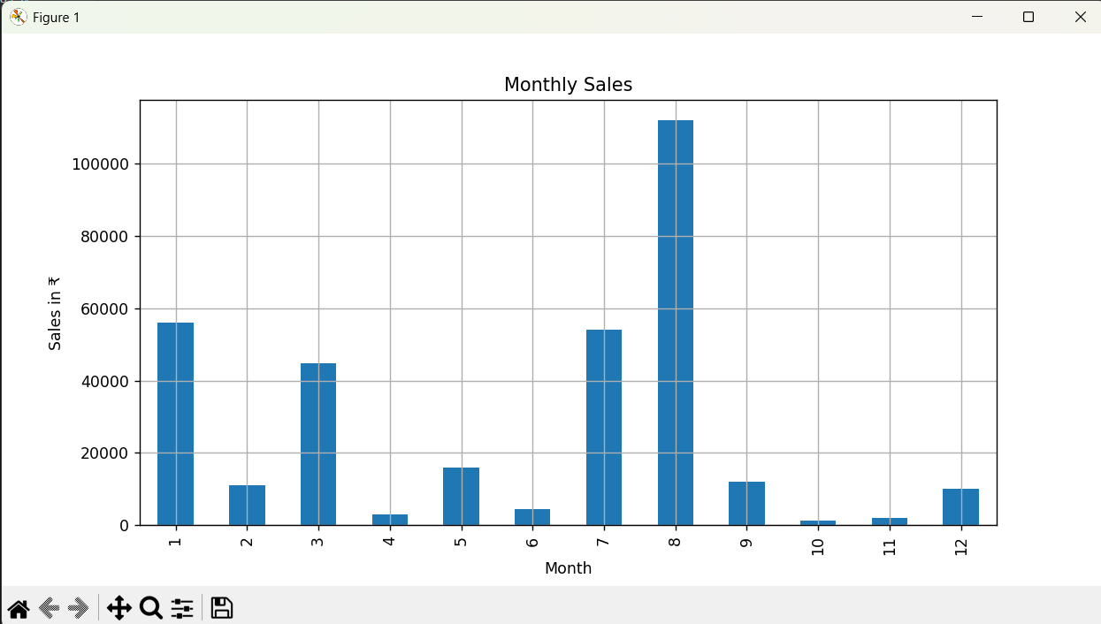

**Top 5 Products by Sales**

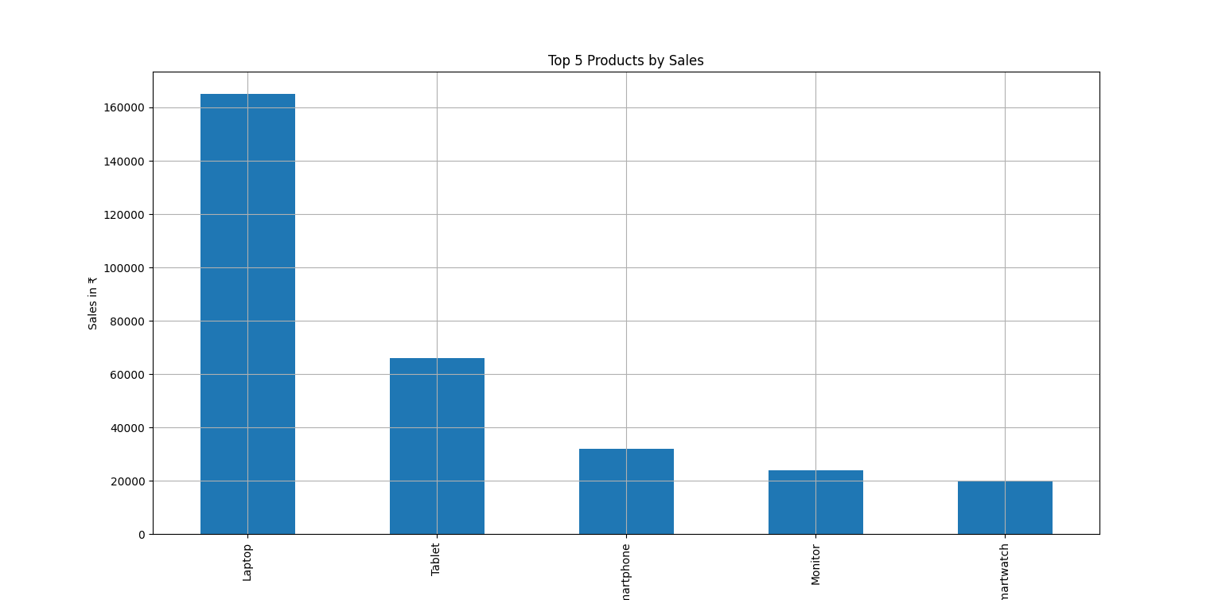

**Monthly Sales Trend Over Time**

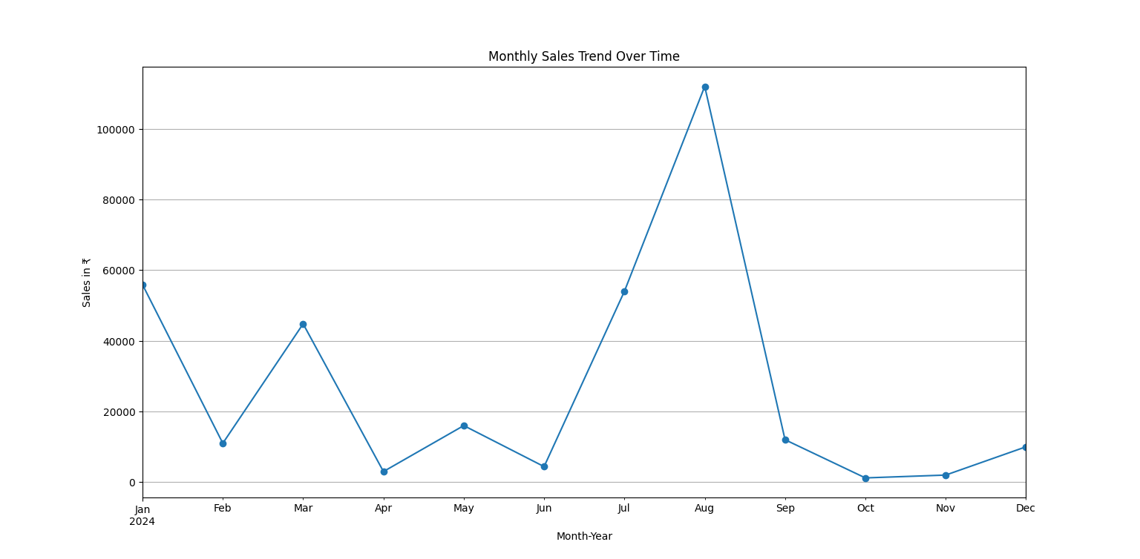

**Most Ordered Products by Quantity**

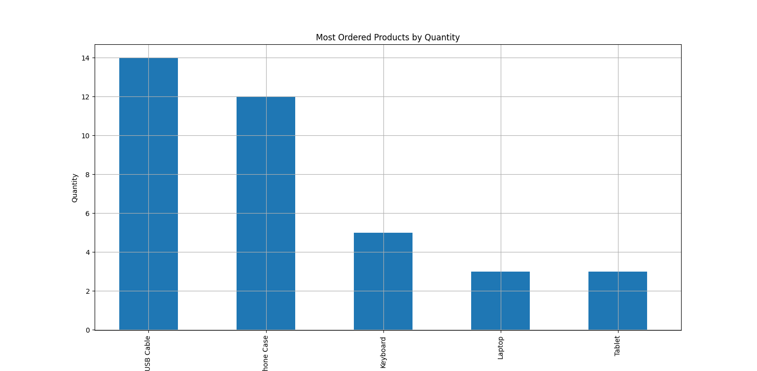

**Sales by Hour**

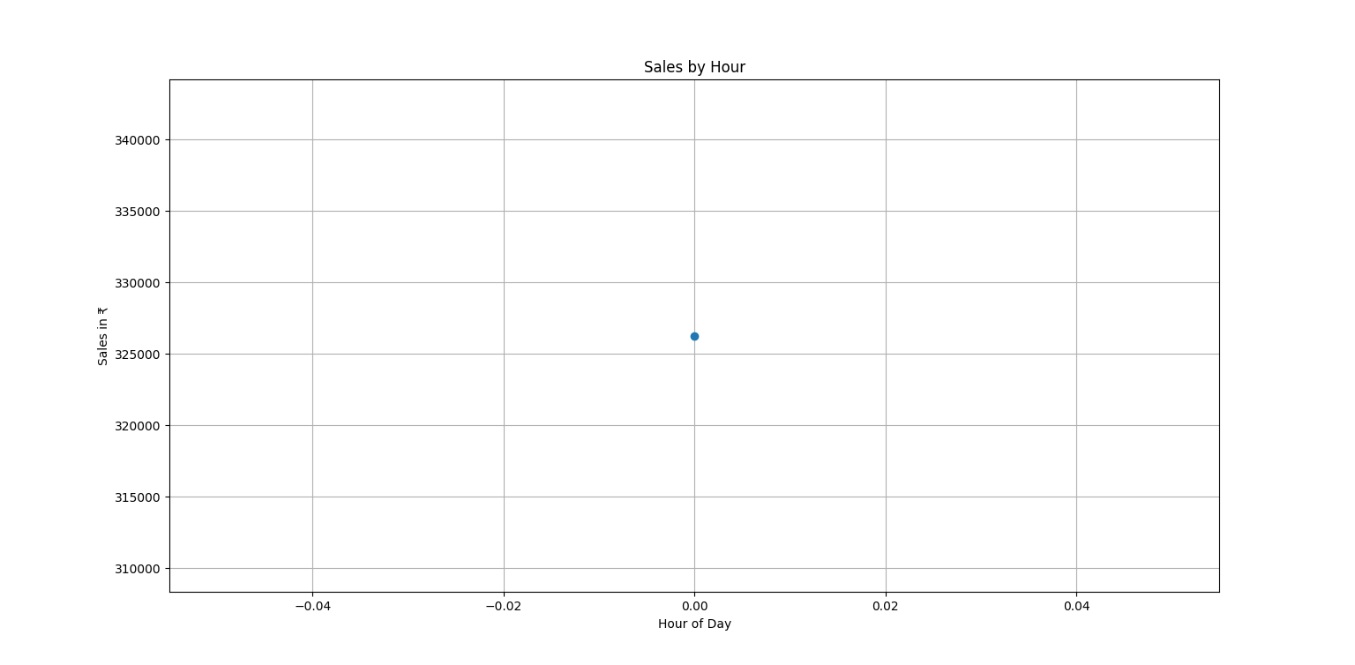

**✅ Conclusion**

This data analysis project successfully visualizes trends in customer purchasing behavior using Python.  
Insights gained from this dashboard can be used by businesses to:

* Improve inventory planning
* Launch targeted marketing campaigns
* Optimize operations during peak hours
* Increase overall sales by focusing on high-demand products

In future, this dashboard can be enhanced with customer segmentation, category-wise analysis, or even machine learning for prediction.